# TO SUPPLY LEFTOVER FOOD TO POOR

College name: A.V.P. College of arts and science

College code: bruaj

TEAM ID: NM2025TMID25476 TEAM MEMBERS:

Team leader name: BARGATH NISHA.A

Email: bargathnisha2006@gmail.com

Team member 1: SWATHI .L

Email: swathiswathi7198@gmail.com

Team member 2: SIVA SANKARI.S

Email: sivasankari87540@gmail.com

Team member 3: PRIYA DHARSHINI. Email:priyadharshiniselvakumar2005@gmail.com

# 1.INTRODUCTION

1.1 Project overview

Food wastage is a major global concern, while millions go hungry every day. This project aims to bridge that gap by collecting leftover, yet edible and hygienic food from restaurants, events, households, and other sources, and redistributing it to the underprivileged and homeless communities. The initiative focuses on reducing food waste while addressing hunger in local neighborhoods.

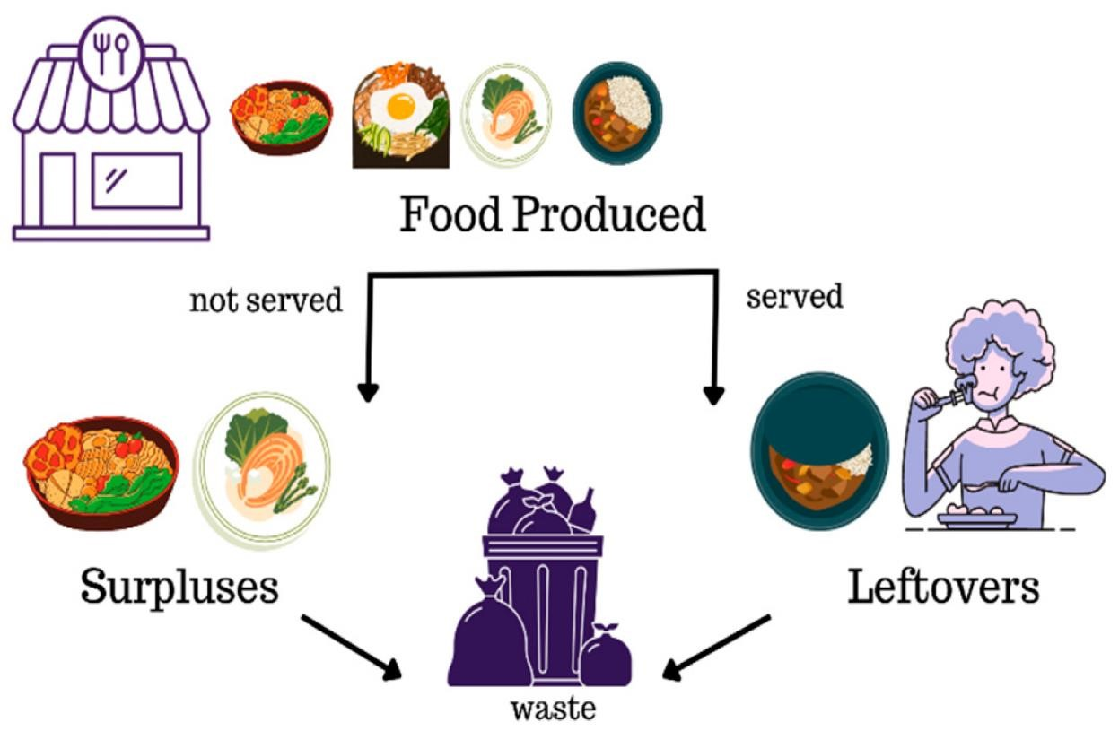

1.2 Purpose

The purpose of this project is to minimize food waste and combat hunger by collecting surplus or leftover food from restaurants, hotels, events, and households, and redistributing it to underprivileged and food-insecure communities. This initiative aims to create a sustainable and organized system for food recovery and donation, promoting social welfare, environmental sustainability, and community responsibility.

DEVELOPMENT PHASE

**Creating developer account:**

By using this URL -<https://developer.salesforce.com/signup>

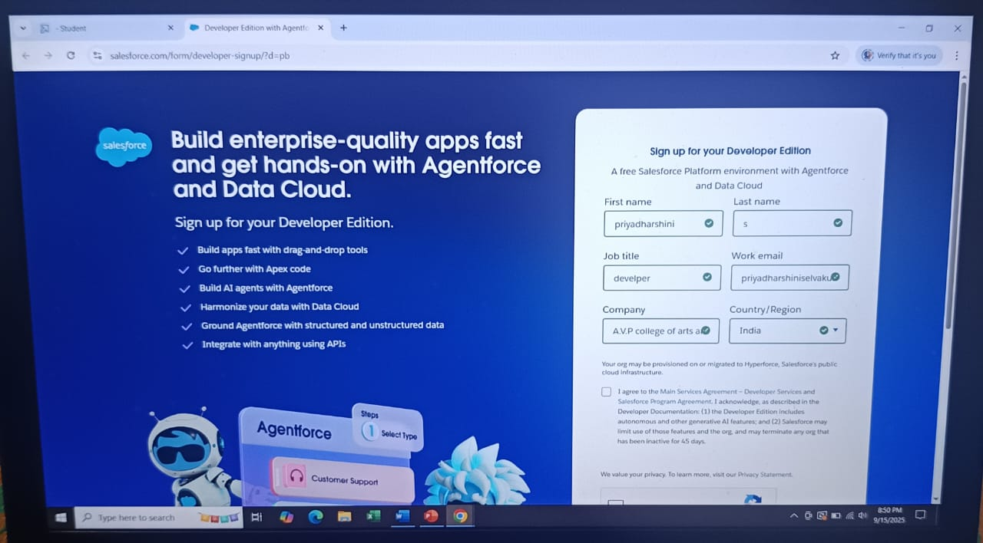

* Created objects: Venue, Drop-Off Point, Task, Volunteer, Execution Details.

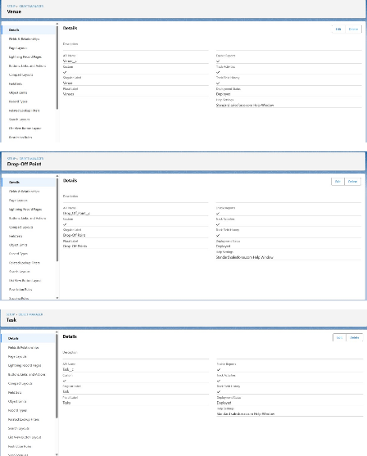

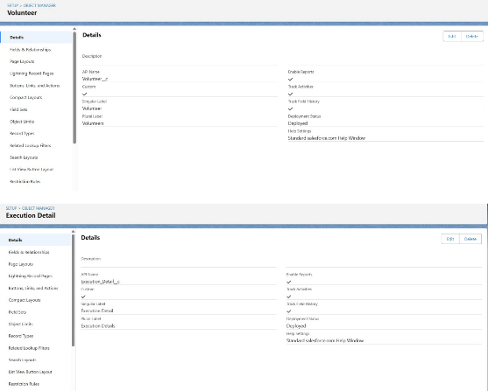

* Creating custom tabs: Venue, Drop-Off Point, Task, Volunteer, Execution Details.

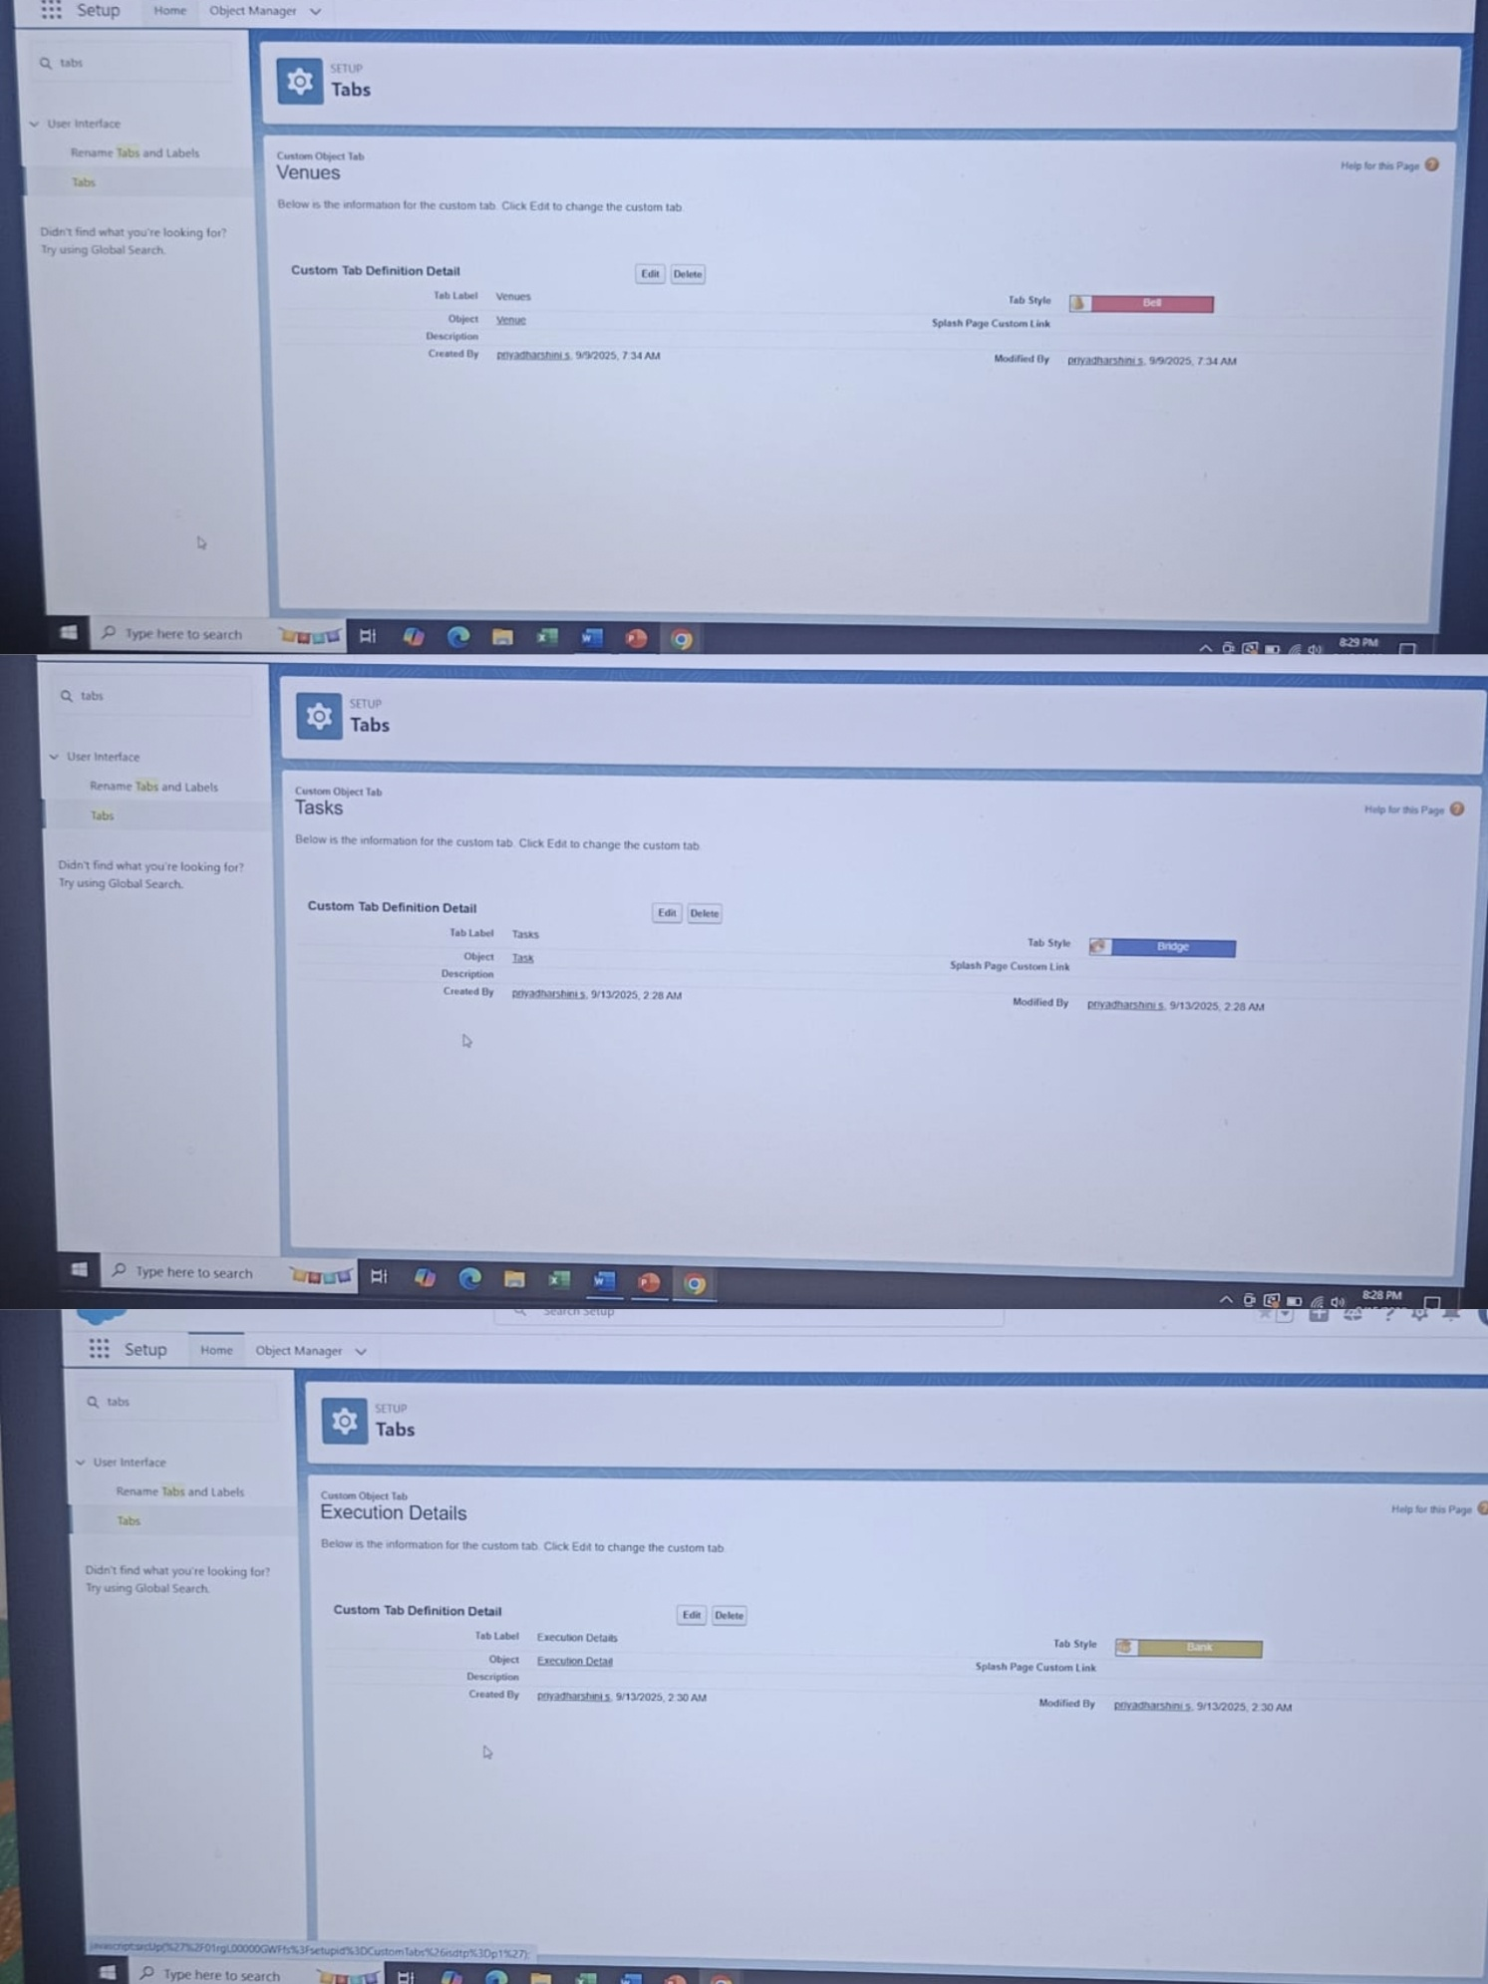

* Creating lightning app.

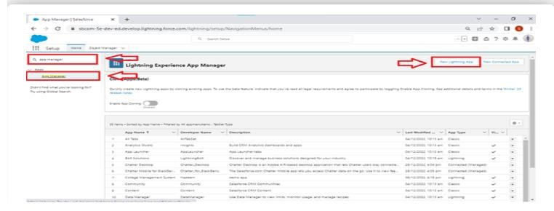

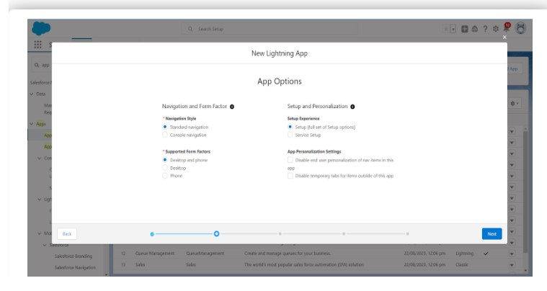

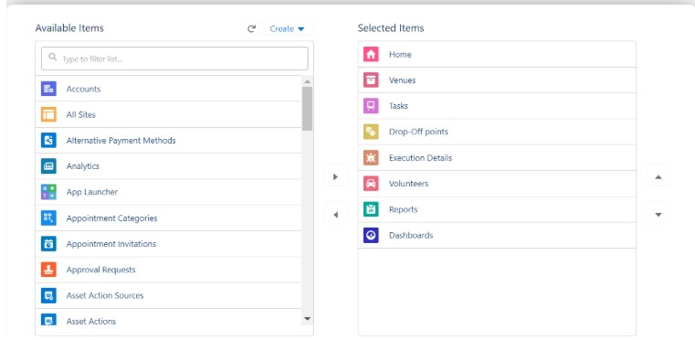

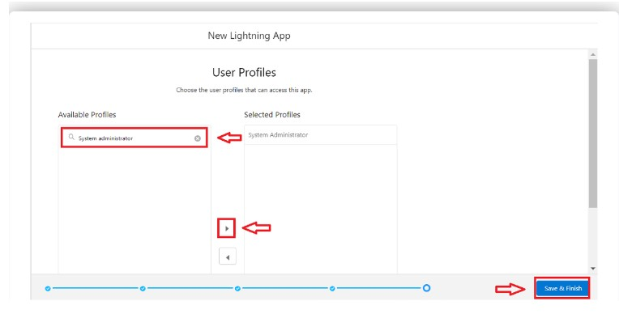

* Creating fields and relationships.

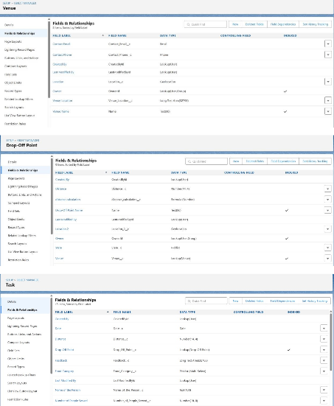

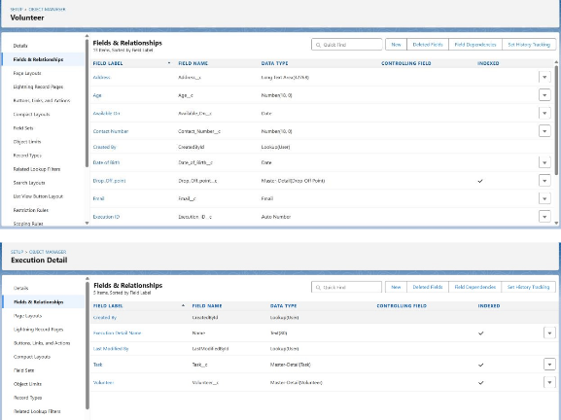

* Creating flows to create a record in venue object.

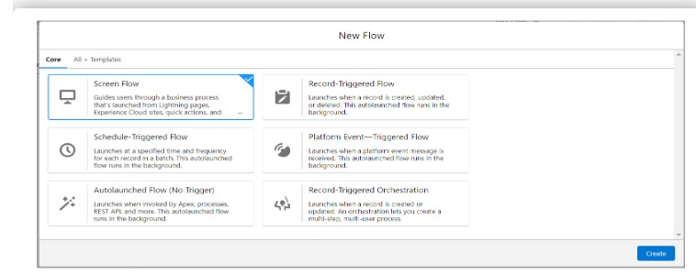

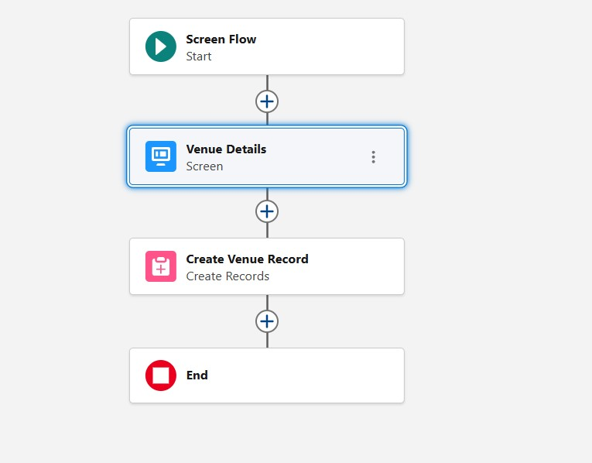

* Creating Trigger code.

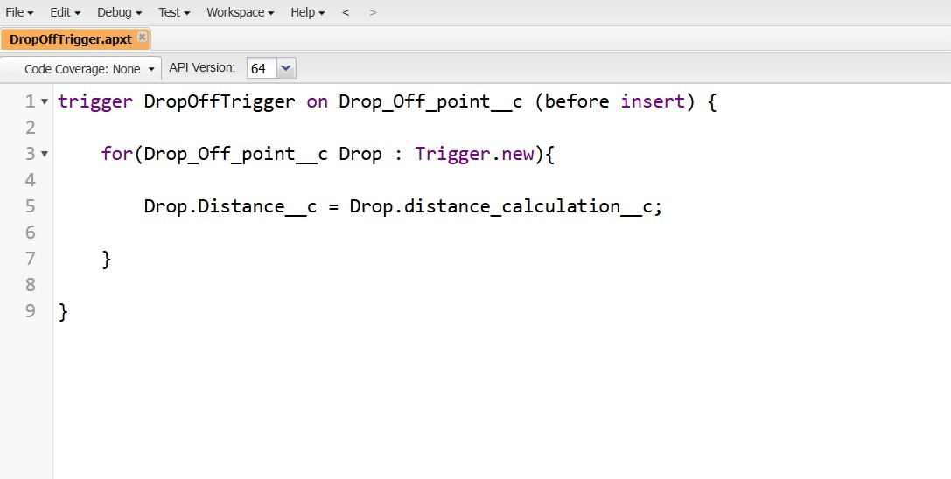

* Creating profiles.

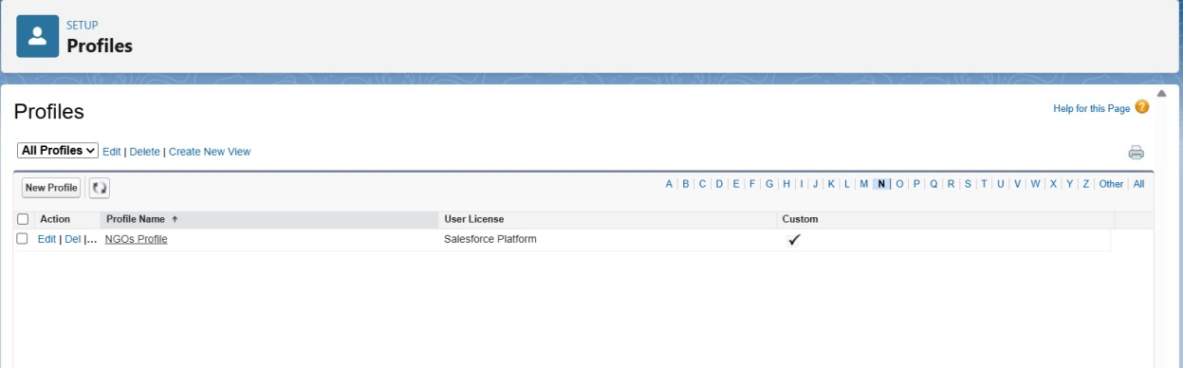

* Creation of users.

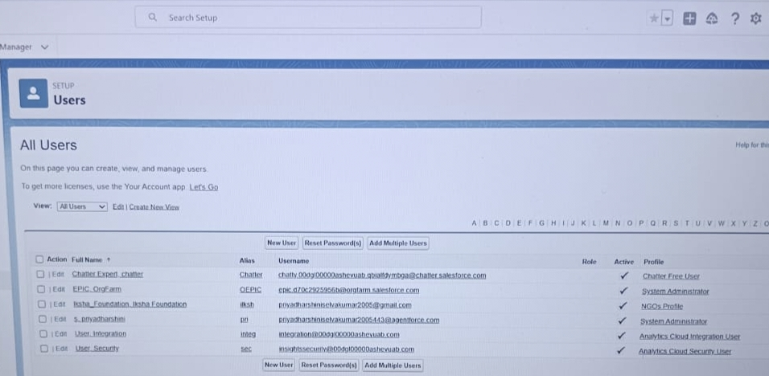

* Creation of public groups.

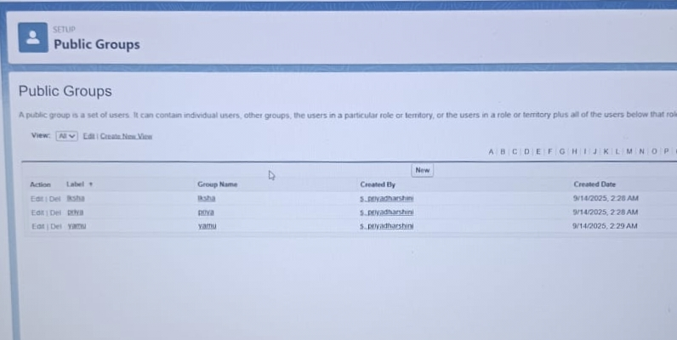

* Creation of report types.

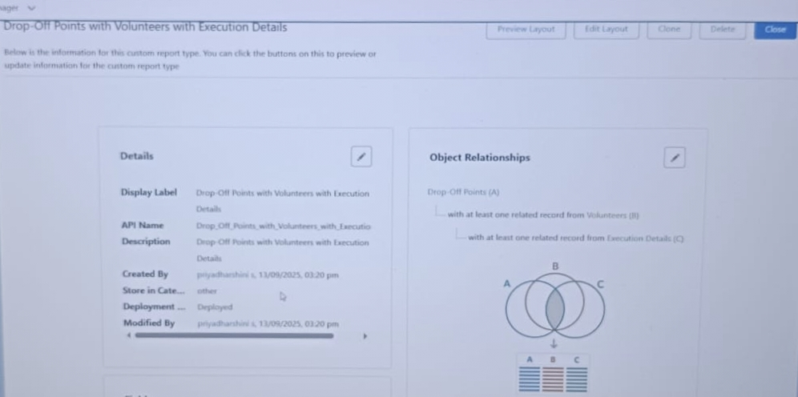

* Creation of Report on Venue with Drop Off with Volunteer

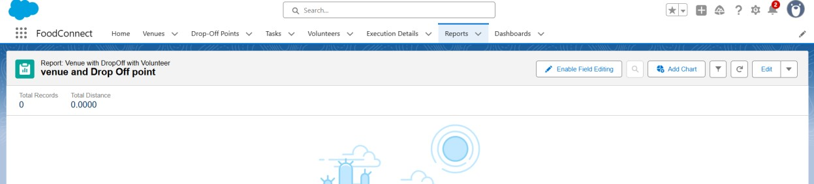

* Creation of Report on Volunteers with Execution Details and Tasks.

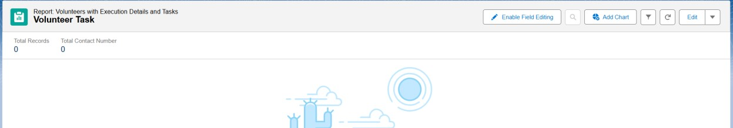

* Creation of dashboard.

* + - Adding venue and Drop Off point Report to the dashboard.

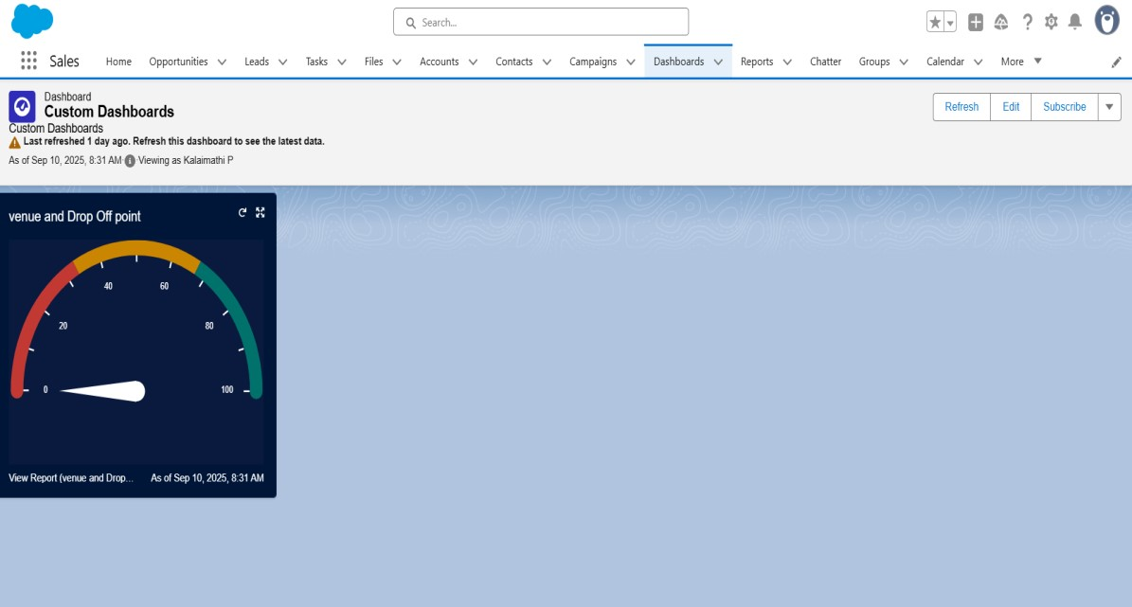

* + - Adding Volunteer Task Report to the dashboard.

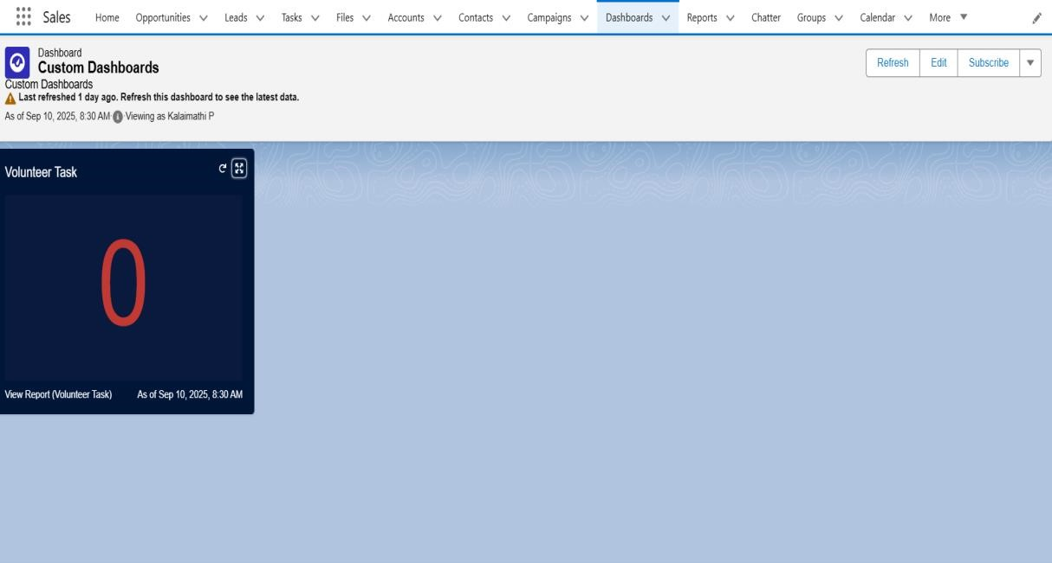

* + - Adding a picture to the dashboard.

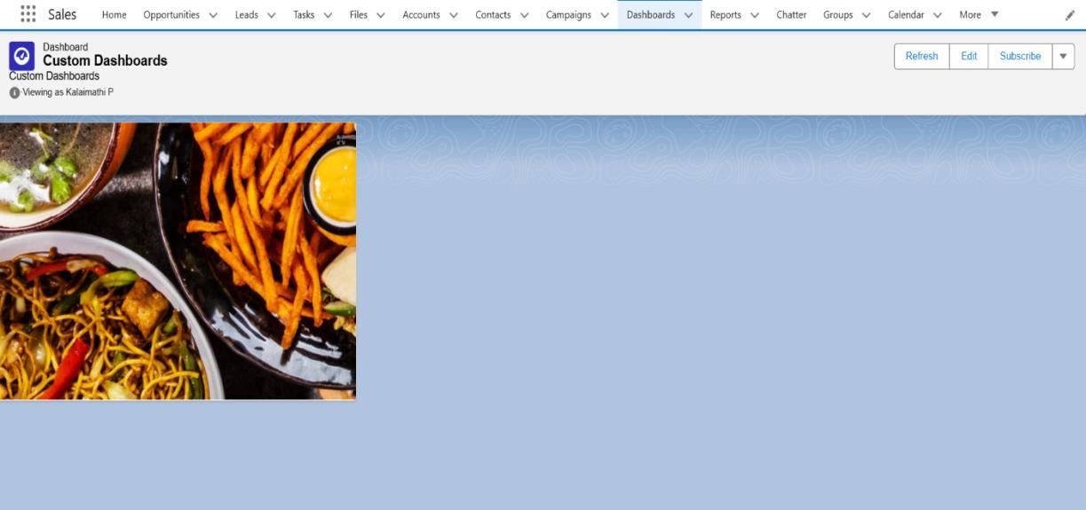

* Creation of sharing rules.

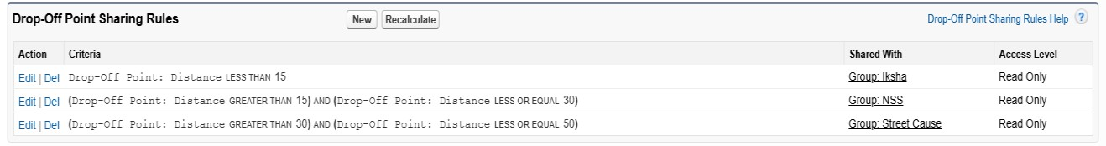

* Creation of home page.

* + Home page of Food connect app.

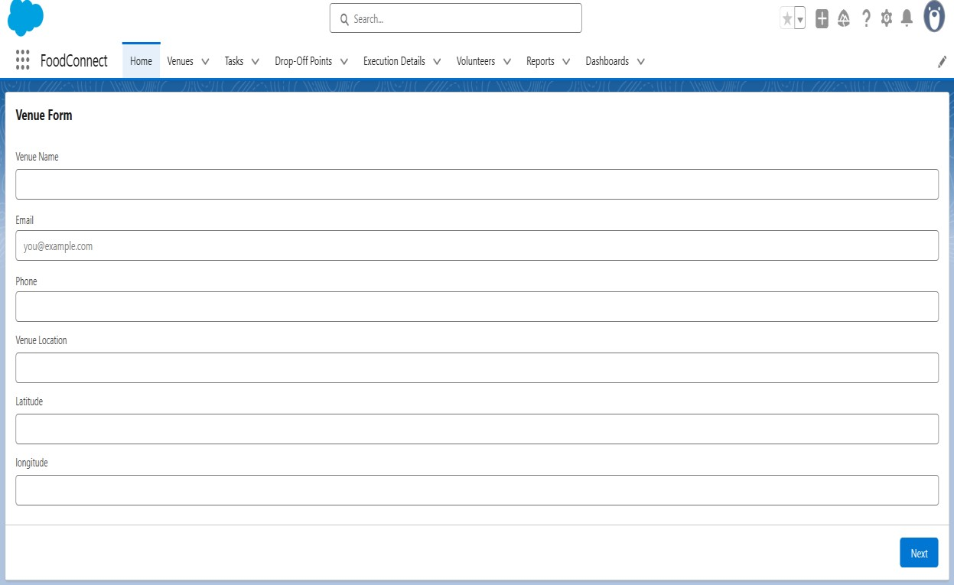

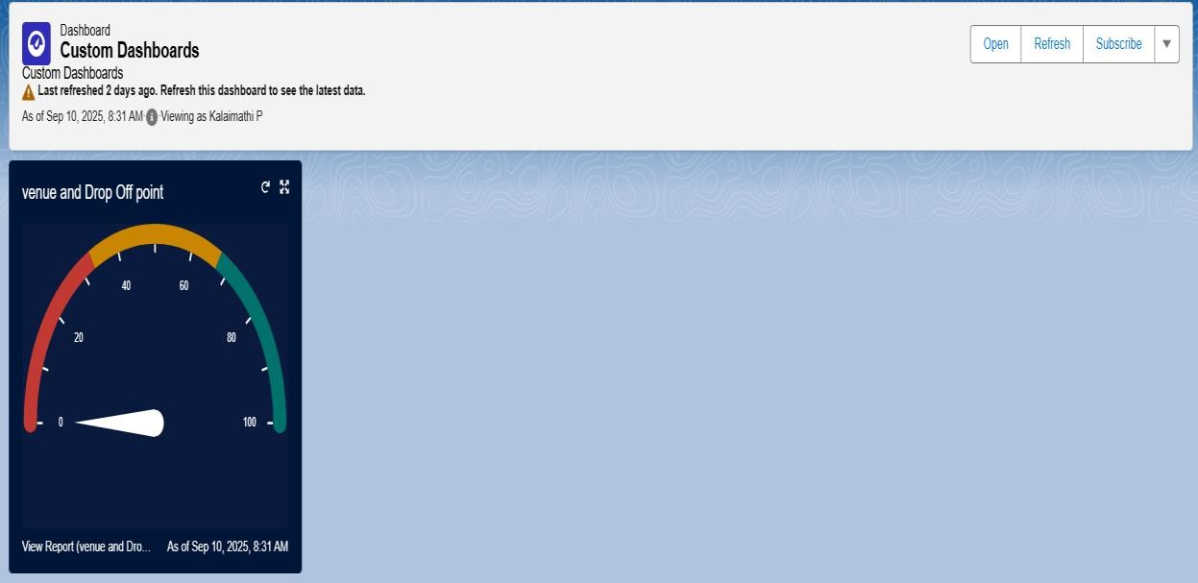

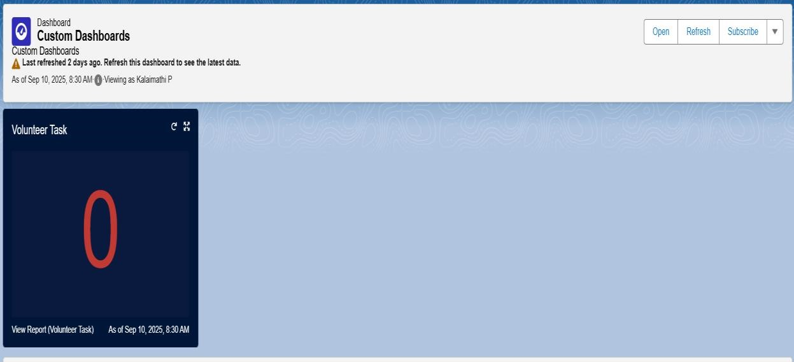

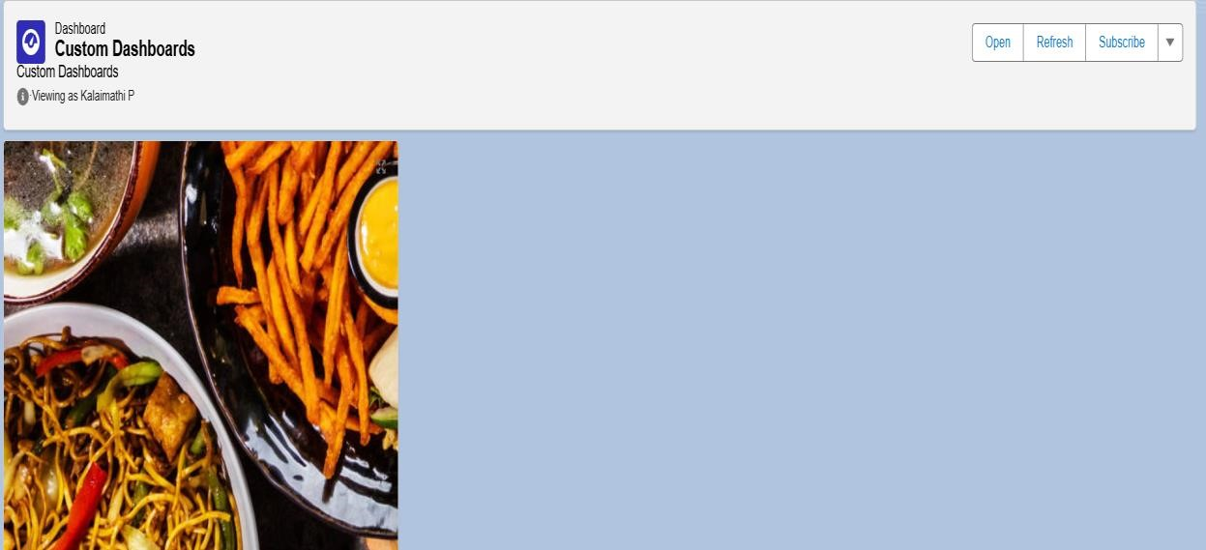

ADVANTAGES AND DISADVANTAGES ADVANTAGES:

* + **Reduces Hunger:**
* Helps feed the poor and homeless who might otherwise go without food.
* **Minimizes Food Waste:**
  + Prevents good, edible food from being thrown away by hotels, restaurants, events, and households.
* **Promotes Social Responsibility:**
  + Encourages individuals and organizations to think about their impact and give back to society.
* **Cost-Effective Solution:**
  + Utilizes already prepared food, reducing the need for additional resources to cook meals.
* **Environmental Benefits:**
  + Reduces the burden on landfills and lowers greenhouse gas emissions caused by rotting food waste.
* **Community Engagement:**
  + Brings together volunteers, NGOs, and local businesses in a meaningful social cause.

DISADVANTAGES:

* **Food Safety Concerns:**

* + If not stored or handled properly, leftover food can spoil and cause health issues.

* **Logistical Challenges:**

* + Collecting, storing, and distributing food quickly and safely requires strong planning and infrastructure.

* **Irregular Supply:**

* + Leftover food may not be available consistently, making it hard to rely on this as a steady food source.

* **Legal & Liability Issues:**

* + Restaurants and food donors might be hesitant to participate due to fear of legal consequences if someone falls ill.

* **Lack of Awareness:**

* + Many people and organizations may not know how or where to donate leftover food.

* **Short Shelf Life:**
  + Leftover food has a limited time before it becomes unsafe to eat, requiring quick action and fast delivery.

CONCLUSION:

The initiative to supply leftover food to the poor is not just a step toward reducing hunger, but also a significant stride in minimizing food wastage and promoting social responsibility. By bridging the gap between food surplus and food scarcity, this project empowers communities to work together toward a more equitable society. Through proper collection, storage, and distribution of edible leftover food, we can ensure that no meal goes to waste and no person sleeps hungry. With continued awareness, support from volunteers, and collaboration with local businesses and organizations, this mission has the potential to create a sustainable impact on both hunger and food waste across the nation.